**Assignment – 03[05/06/2024]**

**Task 1:** **Create an infographic illustrating the Test-Driven Development (TDD) process. Highlight steps like writing tests before code, benefits such as bug reduction, and how it fosters software reliability.**

**Test-Driven Development (TDD)**

Test-driven development (TDD) is a software development approach where tests are written before the actual code is implemented. It involves several steps:

**TDD**

**1. Write a Test:**

* Start by creating a test that defines the desired behavior of the software component.
* The test should be specific, focused, and ideally cover one small piece of functionality.

**2. Run the Test (and fail):**

* Execute the test against the empty or incomplete codebase.
* Since the code does not exist or is incomplete, the test is expected to fail.

**3. Write the Code:**

* Implement the code necessary to pass the test.
* Keep the implementation simple and focused on making the test pass.

**4. Run the Test (and Pass):**

* Execute the test again after writing the code.
* If the code behaves as expected, the test should pass.

**5. Refactor (if needed):**

* Once the test passes, refactor the code to improve its design, readability, or performance.
* Ensure that all tests continue to pass after refactoring.

**6. Repeat:**

* Repeat the process for each new piece of functionality or requirement.
* Write a failing test, implement the code to make it pass, and refactor if necessary.

**Benefits of TDD:**

**1. Bug Reduction:**

* Writing tests before implementing code helps developers think about potential edge cases and error scenarios upfront.
* This proactive approach helps identify and address bugs early in the development process, reducing the likelihood of introducing defects into the codebase.

**2. Improved Software Reliability:**

* TDD leads to more robust and reliable software because each component is tested against its expected behavior.
* Automated tests provide a safety net that ensures code changes do not inadvertently break existing functionality.
* Code is continuously validated against tests, reducing the likelihood of shipping defective software.

**3. Design Improvement:**

* TDD encourages developers to write modular, loosely coupled code that is easier to maintain and extend.
* The iterative nature of TDD promotes better design decisions and cleaner code architecture.
* Refactoring is an integral part of the TDD process, allowing developers to continuously improve the codebase.

**4. Faster Development Cycle:**

* TDD may seem slower initially due to the overhead of writing tests upfront, but it often results in faster overall development cycles.
* By catching bugs early and providing quick feedback, TDD reduces the time spent on debugging and fixing issues later in the development process.
* TDD also encourages smaller, incremental changes, leading to more predictable development timelines.

In conclusion, Test-Driven Development promotes higher quality, more reliable software through early and continuous testing. It fosters a disciplined approach to development, improves code quality, and ultimately leads to faster delivery of software with fewer defects.

**Task 2:** **Produce a comparative infographic of TDD, BDD, and FDD methodologies. Illustrate their unique approaches, benefits, and suitability for different software development contexts. Use visuals to enhance understanding.**

**1. Test-Driven Development (TDD):**

**Approach:** Write tests before writing code, focusing on small units of functionality.

**Benefits:**

* Early bug detection and reduction
* Improved code quality
* Faster development cycles

**Suitability:** Ideal for Agile development environments, iterative development, and projects where requirements are expected to evolve.

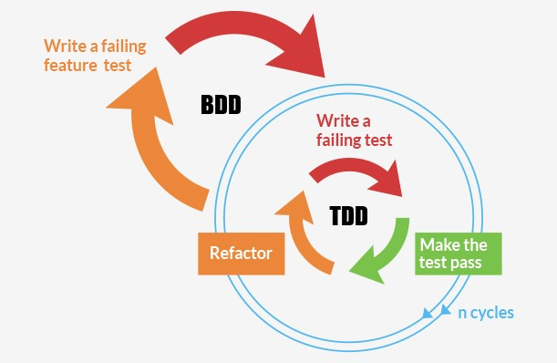

**2. Behavior-Driven Development (BDD):**

**Approach:** Focuses on behavior and outcomes rather than specific code implementation. Uses a domain-specific language to describe desired behavior in user stories.

**Benefits:**

* Improved communication between stakeholders
* Aligns development with business objectives
* Encourages collaboration between developers, testers, and business analysts

**Suitability:** Particularly useful for projects with complex business logic, cross-functional teams, and a strong emphasis on collaboration and communication.

**Flow Chart of BDD:**

Start

Write a failing test

Write a code to make it pass

Refactor

stop

**3. Feature-Driven Development (FDD)**:

**Approach:** Break down development into small, feature-based increments. Emphasizes domain modeling, iterative development, and regular builds.

**Benefits:**

* Focuses on delivering tangible features
* Encourages clear project tracking and progress monitoring
* Promotes scalability and adaptability to changing requirements

**Suitability:** Well-suited for large-scale projects with complex requirements, where a structured, feature-centric approach is necessary.